**FOOD EXPRESS App**

"FoodExpress” is a user-friendly and dynamic online food order platform designed to bring the convenience of restaurant dining to your doorstep. This platform offers a seamless experience for customers to browse restaurant menus, place orders, and provide ratings in real-time, all from the comfort of their homes. The system also empowers restaurant owners to manage their menus and orders efficiently, ensuring smooth operation and timely delivery of food.

Modules to be implemented

1. User Management
2. Restaurant Menu Management
3. Order Management
4. Feedback Management
5. Reports Management

Sample Screen – home:

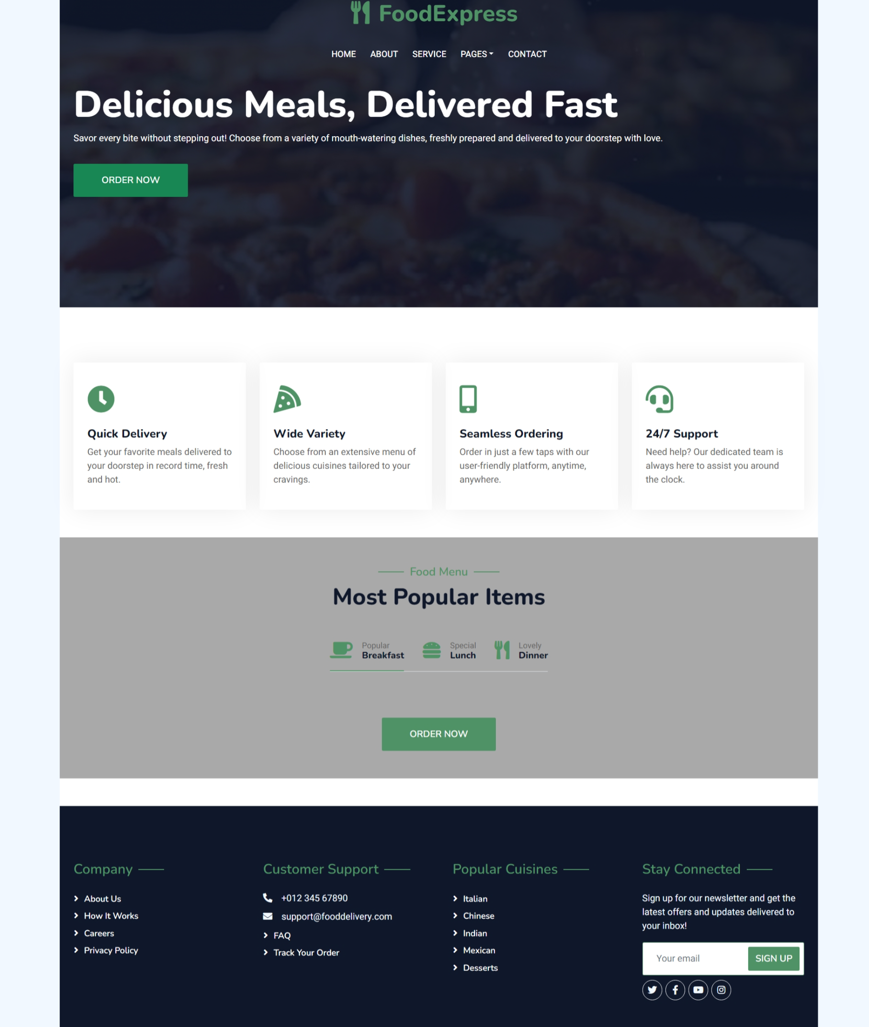

**USER MANAGEMENT**

* The system should allow new users to register by providing basic details such as name, contact information, and delivery address. A unique user ID is automatically generated for every new registration.
* Customers should have the ability to update their personal details (e.g., address or contact information) within the system.
* The system should provide a feature to deactivate user accounts, ensuring that inactive customers are no longer able to place orders or access the platform.
* Users should be able to view their order history and manage their account preferences easily.

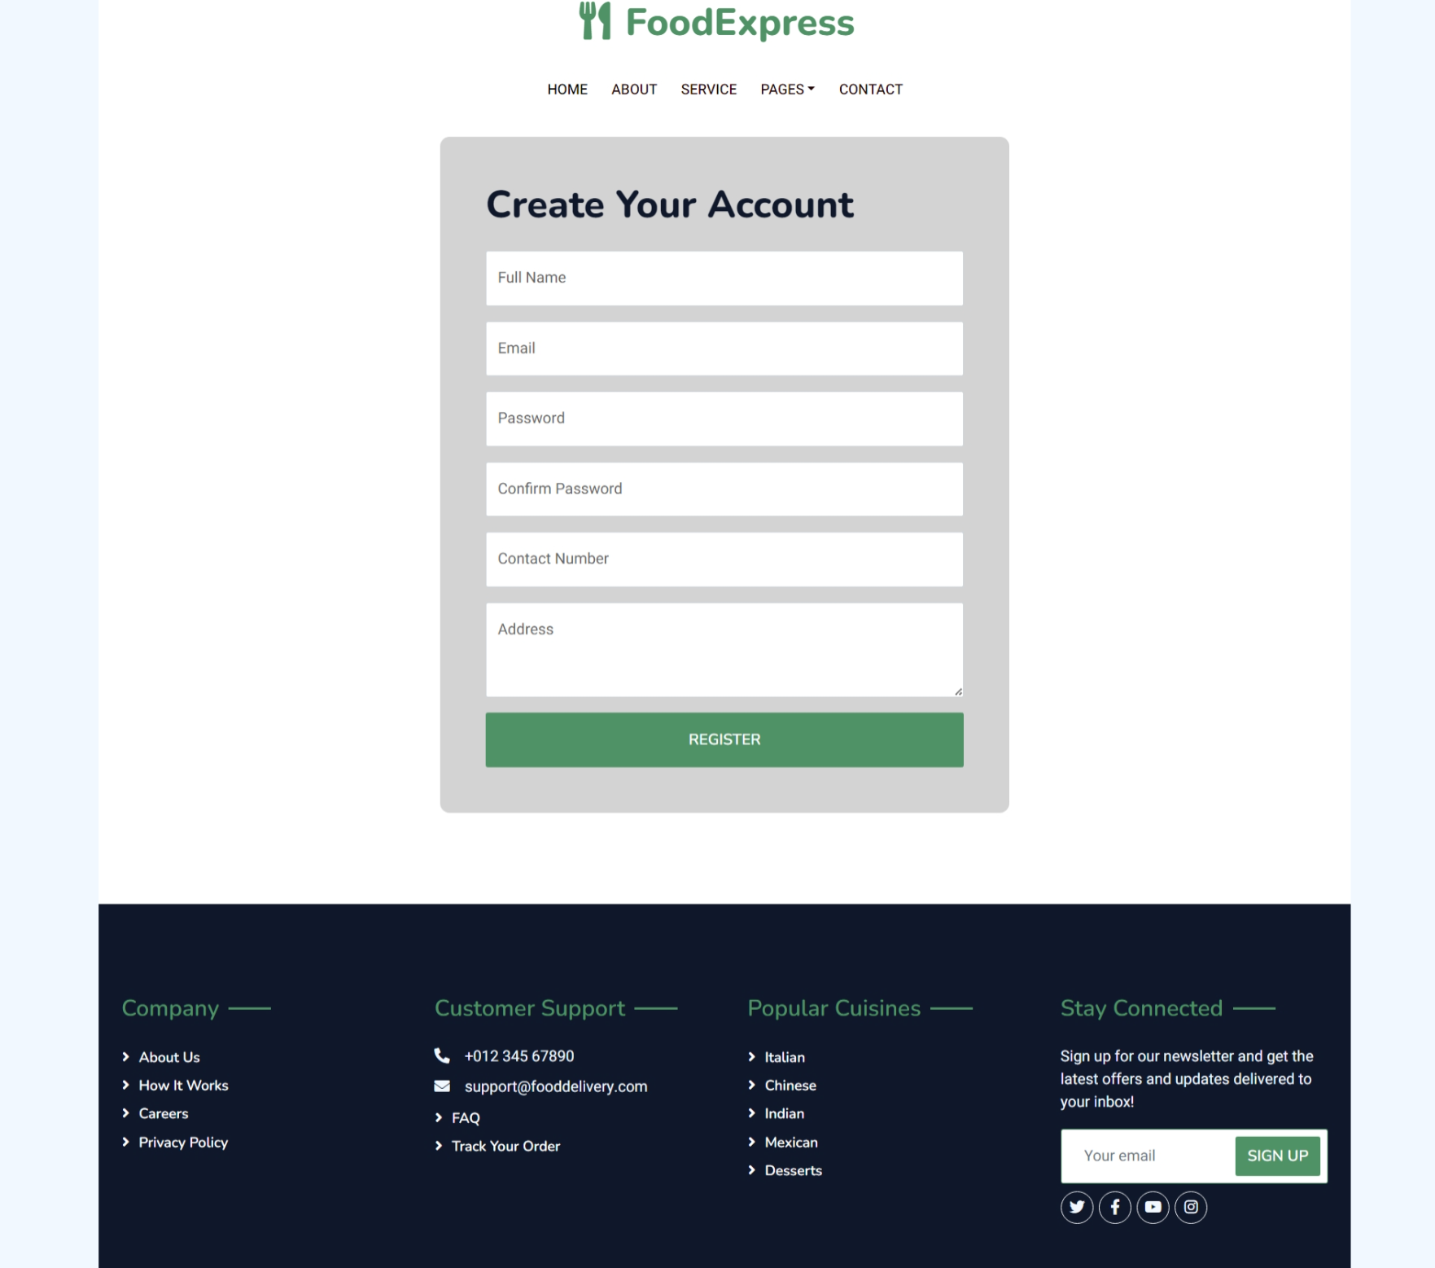

**RESTAURANT MENU MANAGEMENT**

* Restaurants should be able to create and manage their menus, adding details like dish names, descriptions, prices, and availability.
* The system should allow restaurants to update the menu in real-time, such as adding new dishes, removing out-of-stock items, or changing prices.
* The system should allow restaurants to delete items from the menu when they are no longer offered, ensuring the menu remains up-to-date and accurate for customers
* The system should allow restaurants to view detailed information about each menu item, including its description, price, and current stock status, all in one place for easy management.

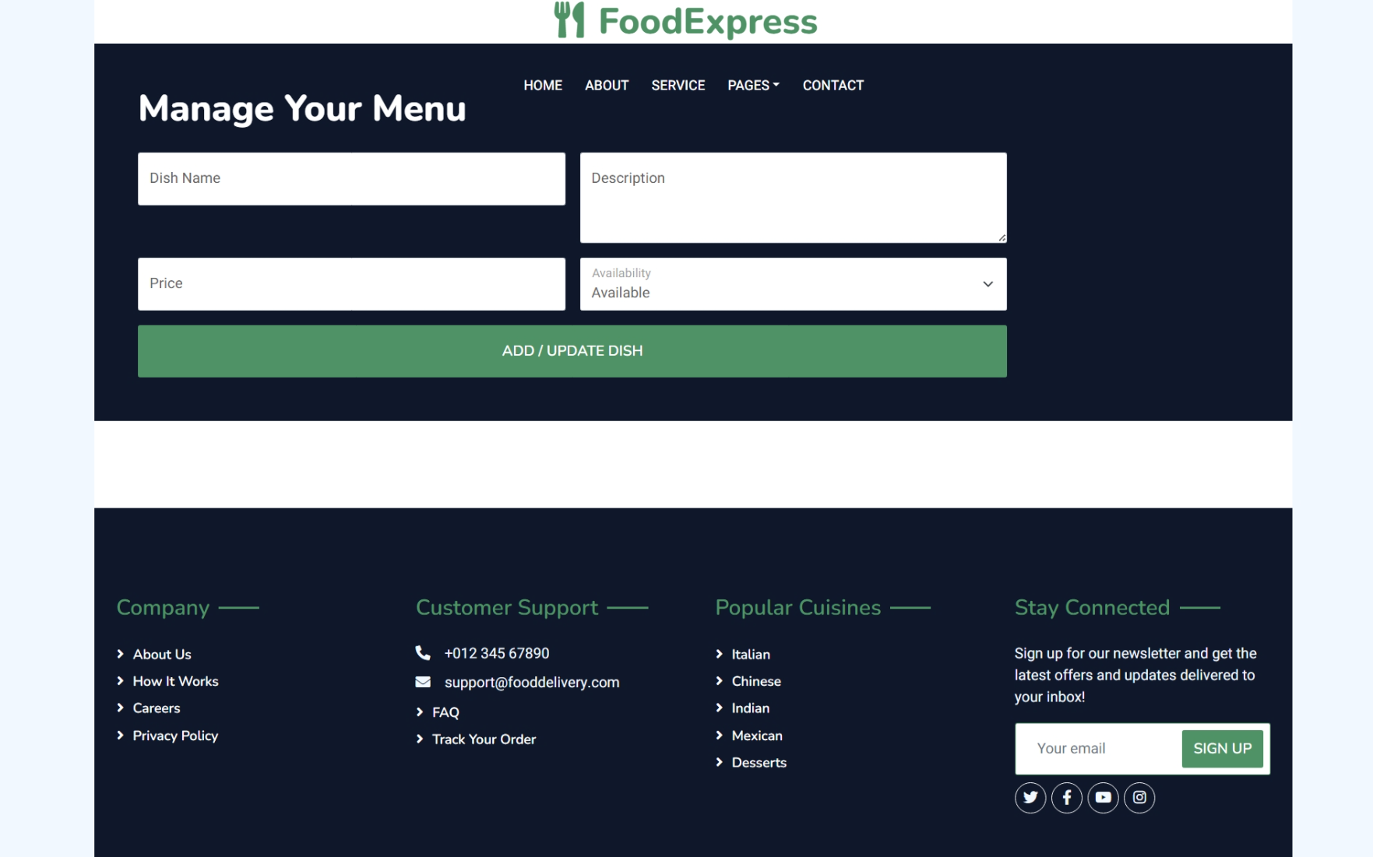

**ORDER MANAGEMENT**

* Customers should be able to browse available menus, select items, and place orders through the system. A unique order ID is generated for every new order placed.
* The system should allow customers to modify their orders before confirmation, such as adding or removing items.
* Restaurants should be able to view and manage incoming orders, including accepting, preparing, and dispatching them.
* The system should provide a feature to cancel or modify an order under certain conditions (e.g., if the order is not yet prepared).

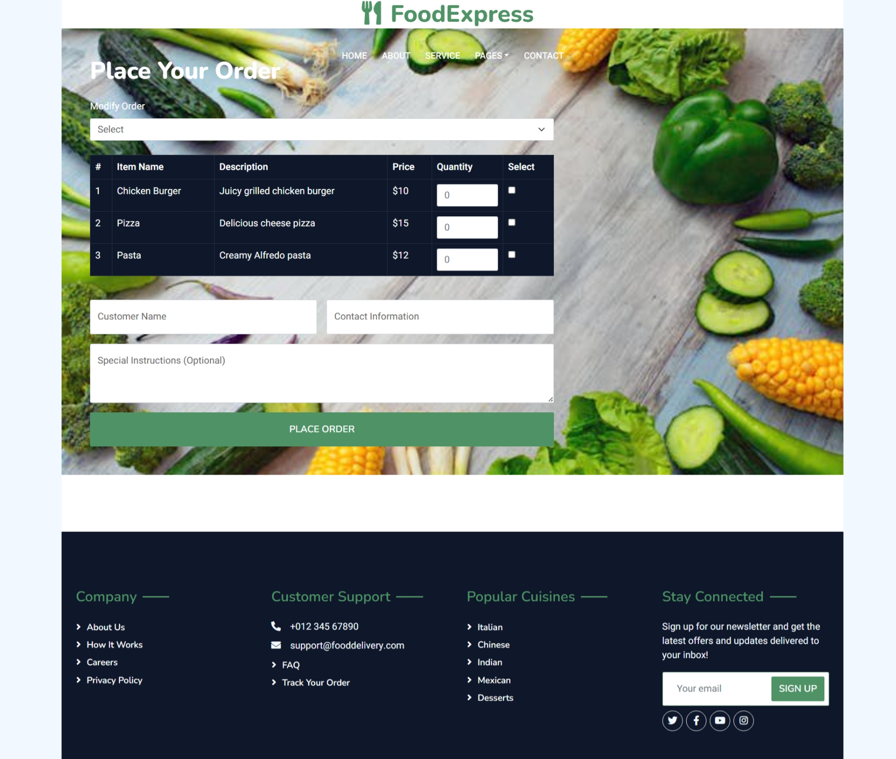

**FEEDBACK MANAGEMENT**

* The system should allow customers to leave written reviews along with ratings, providing valuable feedback to both the restaurant and the platform administrators.
* Restaurants should have the ability to respond to reviews, addressing customer concerns or thanking them for positive feedback.
* System should allow the users to edit the feedback rating or reviews.
* The system should display average ratings for each restaurant, helping customers make informed decisions when choosing where to order from.

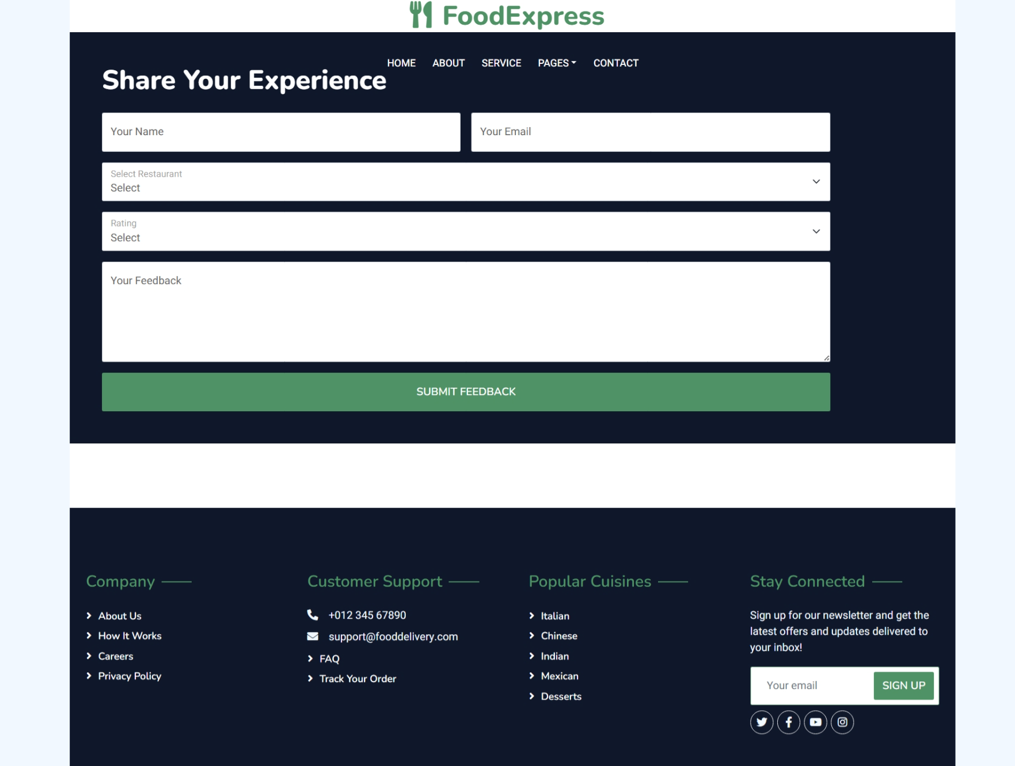

**REPORTS MANAGEMENT**

* The system should allow restaurants to view their entire menu in a list format, showing all items with their names, prices, and availability for quick reference.
* The system should generate daily, weekly, and monthly reports on total orders, order status (completed, pending, canceled), and order value.
* The system should allow administrators to view reports on customer activity, such as the total number of customers, frequency of orders,
* The system should allow restaurants to view aggregated data on customer preferences for menu items, such as the most frequently ordered dishes or popular customizations.

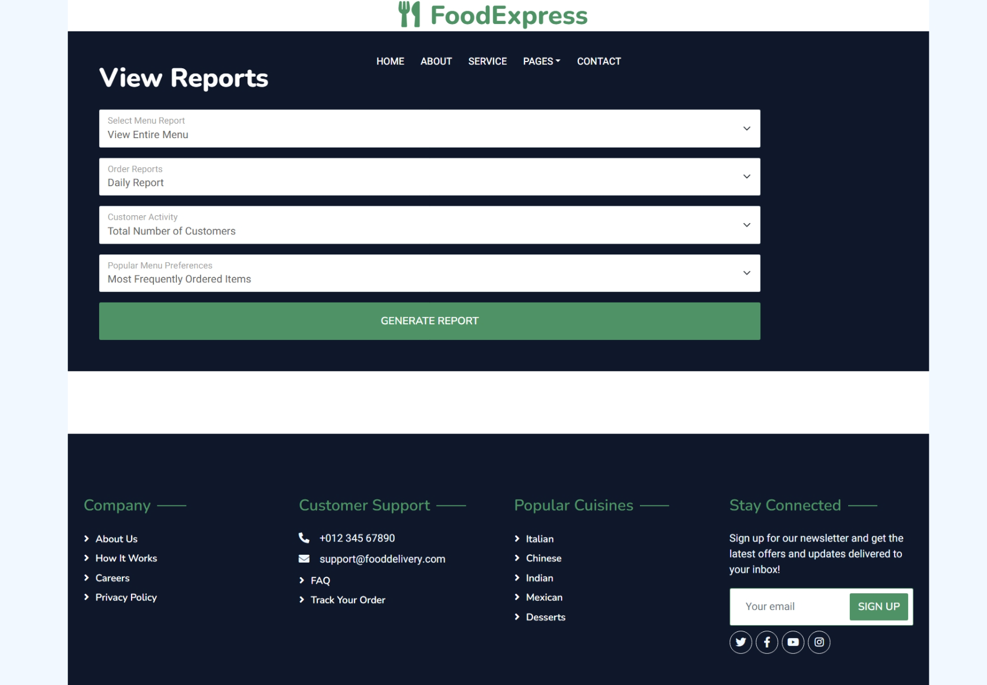

## Artifacts to be done during the project phase:

* Wire Frames
* Database Design
* Use case diagram
* Class Diagram

**Technology Stack:**

**Backend:**

* Java
* Mysql
* Spring Boot Data JPA
* Spring Boot REST Services

**Frontend:**

* Thymeleaf

**Milestone and Tasks:**

|  |  |  |
| --- | --- | --- |
| **Milestone** | **Weeks** | **Expected Task Completion** |
| 1 | Week 1 & 2 | Artifacts |
| 2 | Week 3 & 4 | Backend module implementation |
| 3 | Week 5 & 6 | Frontend module implementation |
| 4 | Week 7 & 8 | Project Integration |

Sample Screens

